April 2, 2024

Salisbury Mayor Randy Taylor
Members of the Salisbury City Council

Dear Mayor Taylor and Salisbury City Council members,
On behalf of the 700+members of the Salisbury Area Chamber of Commerce, we strongly encourage your support of and follow through on the economically significant downtown projects that are underway or on the brink of breaking ground.
The Chamber has stood in support of the progressive development of the downtown corridor since the completion of the citywide Master Plan in 2017 which included all significant stakeholders. Since then, and to this day, large private investments have been made in numerous projects, some now complete, in progress or ready to break ground.
Additionally, the State of Maryland, under two Governors, have acknowledged the economic engine that the capital of the Eastern Shore possesses and committed millions in state investment for the city. The Chamber is concerned that all these commitments, investment and economic development could be in jeopardy.
The Chamber understands that all projects deserve due diligence and proper local review by the Executive and Legislative branches of the city. We also recognize the recent Circuit Court ruling regarding the city’s special exceptions and density provisions. It is our hope that upon appeal, the Court will stand down on the previous decision recognizing the years of investment and planning that complies with the 2017 Master Plan and its elements for all sections of the city.
The Chamber respectfully requests that you honor the contracts that have been properly executed with the developers of these projects dating back to 2017 and allow these significant economic development and job creating projects to move forward. Refrain from returning any state dollars allocated to any part of these projects or face the prospect of little to no future state support on any level for the city.
The Chamber applauds your collective efforts to build a strong and vibrant Salisbury and implore all of you to keep the forward momentum of the city as one of your top priorities.
Respectfully,
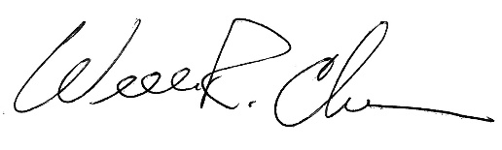
William R. Chambers
President/CEO

